U.S. CONSUMER PRODUCT SAFETY COMMISSION
5 Research Place, Rockville MD 20850

July 9, 2020

TRANSMITTED VIA EMAIL

Ken Kutska
ASTM International
100 Barr Harbor Dr.
West Conshohocken, PA 19428-2959

Re: ASTM Ballot F15 (20-06), Item 12, for Banister Rails/Gliders; F1487-17 Standard Consumer Safety Performance Specification for Playground Equipment for Public Use

Dear Mr. Kutska:
This letter is CPSC staff’s response to ballot Item 12 from ASTM F15 (20-06) ballot on ASTM F1487-17 Standard Consumer Safety Performance Specification for Playground Equipment for Public Use. I am voting negative on this ballot item because as worded, this change would allow unsafe products to be included in the scope of F1487.

Staff is concerned because the proposed ballot would allow glider products that are similar to a glider that already has been recalled to meet the standard (see CPSC’s recall 12-109). CPSC staff is aware of multiple incidents related to these glider products. In 2012, CPSC issued recall 12-109 for a playground glider after CPSC and the firm received 16 reports of injuries to children, including 14 fractures to arms and legs, one fractured collar bone, and one bruised spleen. The glider was recalled due to a clear fall hazard presented by a product with no transition platform at the top and no sides to the chute (see Figure 1).

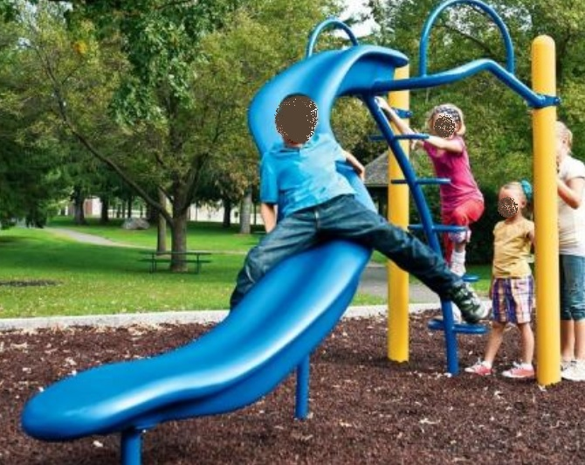
Figure 1. Recalled Playground Glider

CPSC staff requests this ballot item be withdrawn while ASTM and CPSC staff explore more fully the hazards associated with these products.

Sincerely,

Kevin K. Lee
Mechanical Engineer
Division of Mechanical and Combustion

CC: Patricia L. Edwards, CPSC Voluntary Standards Coordinator
Molly Lynyak, ASTM International

The views expressed in this letter are those of CPSC staff and have not been reviewed or approved by, and may not necessarily reflect the views of, the Commission.
https://www.cpsc.gov/Recalls/2012/childrens-slides-recalled-by-landscape-structures-due-to-fall-hazard.

